FRACTURE FIXATION
- prepare the animal and site of the operation
- prepare the theater room and the instruments
- prepare the surgeon and his tem

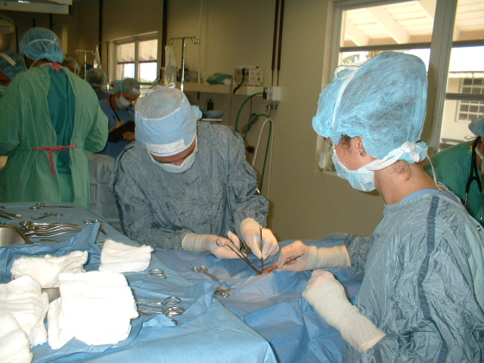1. Prepare the animal and site of the operation.
- General examination for the animal (body temperature, heart beat and pressure, respiratory rate).
- Laboratory test (CBC, differential count, blood chemistry, urine analysis, stool examination).
- Off food 24 hrs and water 6 hrs prior to the operation.
- Prepare the site of the operation (clipping, shaving, wash with soap and tap water, and then disinfect the site of operation).

2. Prepare the theater room and the instruments.
- Prepare the operation room (clean, sterile the room, checking lights, water supply, ventilation).
- Prepare the instruments (prepare and sterile the stander and special set, prepare the drapes).
- Prepare all equipments which essential for operation (anesthetic agents, oxygen, heart stimulant sutures materials, antibiotics, fluid therapy, fixation devices-ray films).

3. Prepare the surgeon and his team.
- Must be in good condition.
- Knowledge Refreshment about the technique and anatomy prior the operation.
- Change the street clothes with the operation clothes.
- Wear the mask and cup
- Prepare and disinfect the hands
- Wear the sterile apron
- Wear the surgical gloves

Veterinary Implants and Instruments
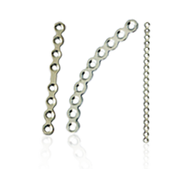
Bone Plates
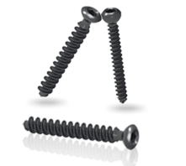
Bone Screws
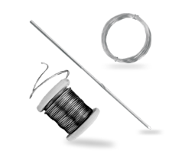
Pins, Wires & Staples
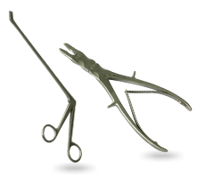
General Instrume

New Products

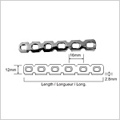
Reconstruction Plate 4.5mm Screws
Model No: 634VET
View Detail
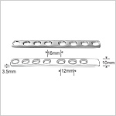
Dynamic Self Compression Plate for Small Fragment for Ulna and Radius
Model No: 617VET
View Detail
Pin Steinmann
Model No: PS901VET
View Detail
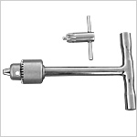
Steinmann pin introducer S.S. with S.S. Chuck & Key
Model No: IPW927VET
View Detail
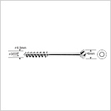
Cancellous Screw 6.5mm
Model No: 721VET
View Detail
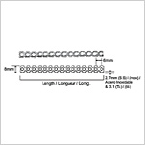
Reconstruction Plate 2.7mm Screws
Model No: 632VET
View Detail

Fractures fixation devices
Internal fixation devices | External fixation devices
- Intramedullary pins | - Cooptation splints
- Compression bone plate with screw | - Mason meta
- Screw | - Plaster of Paris
- Wire circulate | - Air cast (Gypsona).
 | - Modified Thomas splint
 | - Half pin splintage (kirshner splint).

Advantages and disadvantages of fracture fixation devices.
- Intramedullary pins.
Different types,rush,kuenscher,and Steinman
Using in different type of fractures
Need highly aseptic technique
Can be used as retrograde methods or normograde methods
Used in open reduction

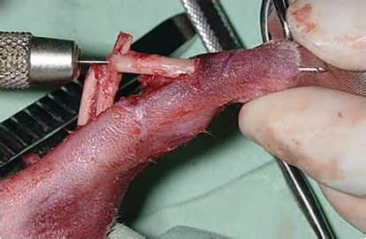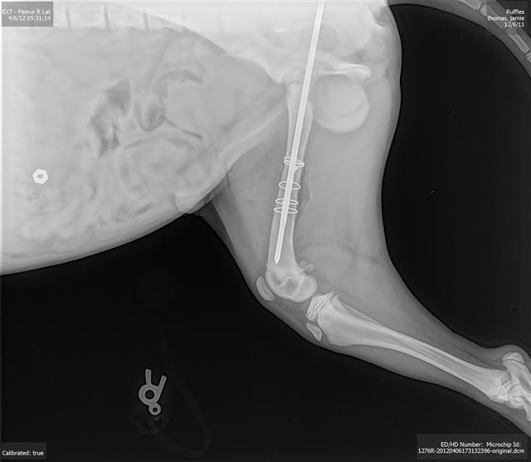
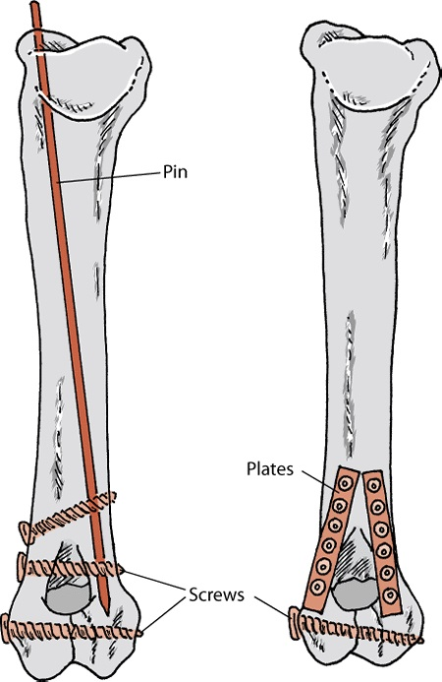

- Compression bone plate with screw.
Lead to rigid fixation | Expensive
Direct or primary fracture healing | Need more device for fixation
highly aseptic technique | May lead to infection
No or little callus formation

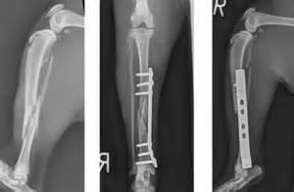
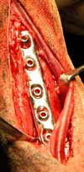
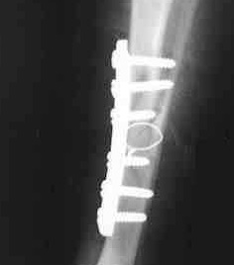
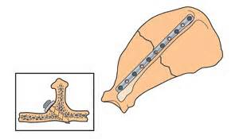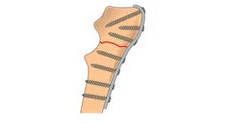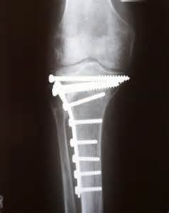

- Screw (Lag screws fixation).
Used in oblique fracture alone
Can be used with bone plate
Can be used with stainless wire
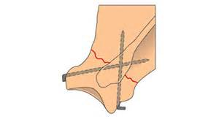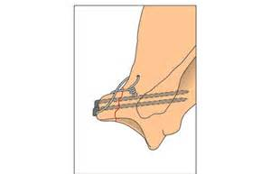

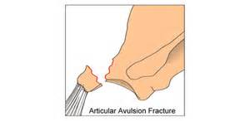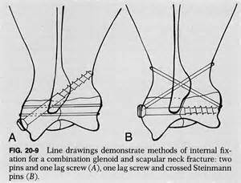

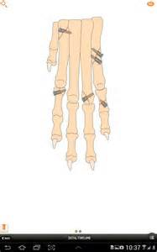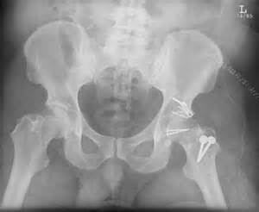

- Wire circulates.

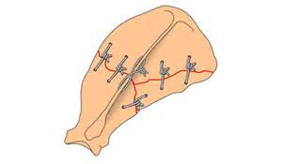
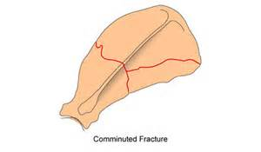

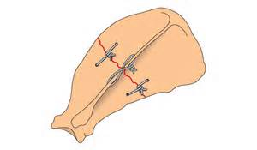

''

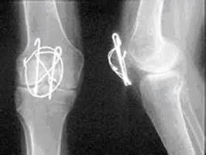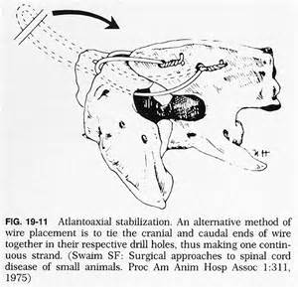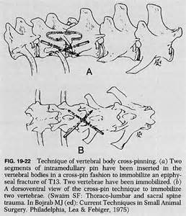
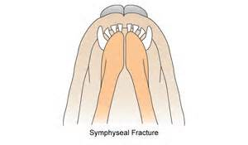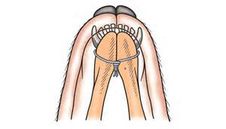

- Cooptation splints.
Wood,almnoum plates,alumafoam | Reexamine the splints 24 hrs later
Using plaster with the splints | Checking for pressure necrosis, or loosen tight
Easy to use | Must remain dry
Active in some types of long bone fractures: simple ,transvers in radius,ulna,tibia ,and fibula | Weekly reexamine the pressure of the splints to avoid its bad affect on the blood circulation
Use it in the fracture of distal end of ,scapula,ribs,and tail
Light weight,strong.small in size
The above and below joint involved
The bone fragment remain in good alignment during fixation
Must not affect on the blood circulation
Can use tongue depressor
Can use pad of cotton

- Mason Meta.
Cast of alumnoum
In metacarpus and metatarsus bones and bones far to these .
In the caudal aspect of the fracture limb
Using pad of cotton in side
Adhesive tape
Can be agustable to fit different size and length of bones

- Plaster of paris (Gypsona).
Hard and dry quickly | May lead to abrasion wound
Not heavy weight and strong | May case pressure necrosis
Can be used in two three layer
Don’t need to clipping hair
Using without pad
Easy to remove by saw
Check the splints 24 hrs ago
best for transverse or epiphyseal fractures, especially in younger animals.
Cast must extend from the foot to include a joint above the fracture site.

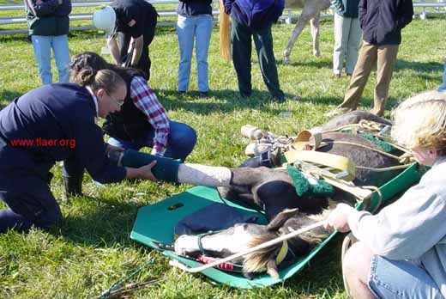

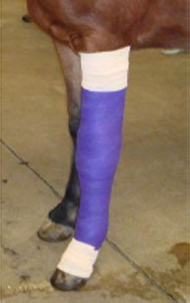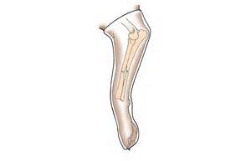

- Aircast
Plstic material
Need catalyst reagent to use and to remove
Water resistant
Allow air to reach the skin

- Modified Thomas splints.
Made of deuraluminum | Aluminum is not useful because easy to broken when bending
Can made of Different size and length,4/3,1/4,and4/8 inches diameter ,and 6and 2 foot long
Can use adhesive tape or bandage around the rode
Can use kirshner wir,Steinman pin for more fixation

- Half pins splintage (kirshner splint)
Half pin in the bone and the other half outside the skin | Need special apparatus to connection and control
Easy to control the bone from outside | Infection can occures
Using in one side of the leg | Need highly aseptic technique
Joints freely movable | Seepage of pins may occurs
Not affect on the blood circulation or muscular atrophy
Modified to half kirshner

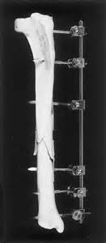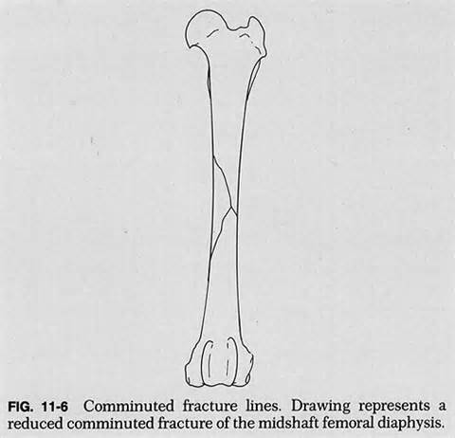

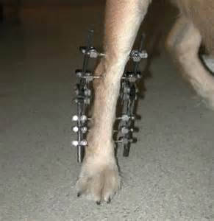
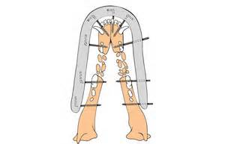
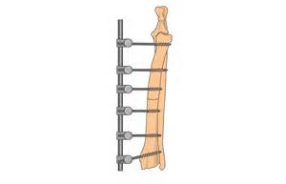
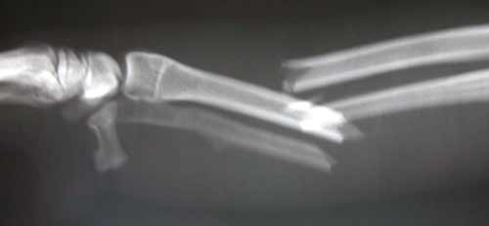
Fracture Surgery

Bone fracture repair
On This Page:

Introduction to the surgical repair of broken bones in dogs and cats

